Performance Tuning for RH-1
Schindler CRD Applications

Exported on 2025-08-19 05:08:50

Table of Contents

1 Reference Article 4
2 WCA Performance Tuning Factors Verification 5
3 Necessary Additional Windchill Tuning 6
4 Types and Attributes Cache properties 7
4.1 Property-1: wt.cache.size.AclCache 7
4.2 Property-2: wt.cache.size.WTPrincipalCache 7
4.3 Property-3: wt.cache.CacheManager.summaryInterval 8
4.4 Property-4: wt.cache.size.NotificationListCache 9
4.5 Property-5: wt.cache.size.PagingSessionCache 9
4.6 Property-6: wt.cache.size.ReferenceCache 9
4.7 Property-7: wt.cache.size.RoleAccessCache 10
4.8 Property-8: wt.cache.size.SessionCache 11
4.9 Property-9: wt.cache.size.StandardUfidSrvService$RemoteObjectIdCache 11
4.10 Property-10: wt.cache.size.StandardFvService$FvMountCache 12
4.11 Property-11: wt.cache.size.StandardFvService$FvFolderCache 13
4.12 Property-12: wt.cache.size.StandardFvService$ActiveFolderCache 13
4.13 Property-13: wt.cache.size.StandardFvService$RootFolderCache 14
4.14 Property-14, 15 & 16: 15
4.15 Property-17: wt.admin.cache.maxDomains 16
4.16 Property-18: wt.cache.size.PreferenceCache 16
4.17 Property-19: wt.services/rsc/default/ObjectReferenceCacheTable/ContainerCache.Size/null/0 17
4.18 Property-20: wt.services/rsc/default/ObjectReferenceCacheTable/ContainerTeamCache.Size/null/0 18
5 Vault Tuning 19
6 Index Tuning 20
7 Database Tuning 21

- Reference Article
- WCA Performance Tuning Factors Verification
- Necessary Additional Windchill Tuning
- Types and Attributes Cache properties
  - Property-1: wt.cache.size.AclCache
  - Property-2: wt.cache.size.WTPrincipalCache
  - Property-3: wt.cache.CacheManager.summaryInterval
  - Property-4: wt.cache.size.NotificationListCache
  - Property-5: wt.cache.size.PagingSessionCache
  - Property-6: wt.cache.size.ReferenceCache
  - Property-7: wt.cache.size.RoleAccessCache
  - Property-8: wt.cache.size.SessionCache
  - Property-9: wt.cache.size.StandardUfidSrvService$RemoteObjectIdCache
  - Property-10: wt.cache.size.StandardFvService$FvMountCache
  - Property-11: wt.cache.size.StandardFvService$FvFolderCache
  - Property-12: wt.cache.size.StandardFvService$ActiveFolderCache
  - Property-13: wt.cache.size.StandardFvService$RootFolderCache
  - Property-14, 15 & 16:
  - Property-17: wt.admin.cache.maxDomains
  - Property-18: wt.cache.size.PreferenceCache
  - Property-19: wt.services/rsc/default/ObjectReferenceCacheTable/ContainerCache.Size/null/0
  - Property-20: wt.services/rsc/default/ObjectReferenceCacheTable/ContainerTeamCache.Size/null/0
- Vault Tuning
- Index Tuning
- Database Tuning

Reference Article
- Please refer the below article for Windchill performance tuning.
Article - CS153338 - Windchill System Initial Performance Tuning

WCA Performance Tuning Factors Verification
- In the Reference Article it is clearly outlined that to pay attention to the prompts below while running WCA.
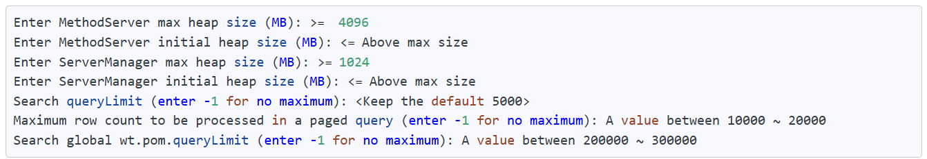

2. Irrespective of WCA suggested values, verified the values in performance.xconf and they are meeting the above criteria.
3. Below are the properties and its values from performance.xconf file.
- <Property name="wt.method.maxHeap" overridable="true" targetFile="codebase/wt.properties" value="10240"/>
- <Property name="wt.method.minHeap" overridable="true" targetFile="codebase/wt.properties" value="10240"/>
- <Property name="wt.manager.maxHeap" overridable="true" targetFile="codebase/wt.properties" value="5120"/>
- <Property name="wt.manager.minHeap" overridable="true" targetFile="codebase/wt.properties" value="5120"/>
- <Property name="com.ptc.windchill.search.queryLimit" overridable="true" targetFile="codebase/wt.properties" value="5000"/>
- <Property name="wt.pom.paging.snapshotQueryLimit" overridable="true" targetFile="db/db.properties" value="-1"/>
- <Property name="wt.pom.queryLimit" overridable="true" targetFile="db/db.properties" value="-1"/>

Necessary Additional Windchill Tuning
- All the additional Windchill tuning properties are meeting the below criteria from the Reference Article
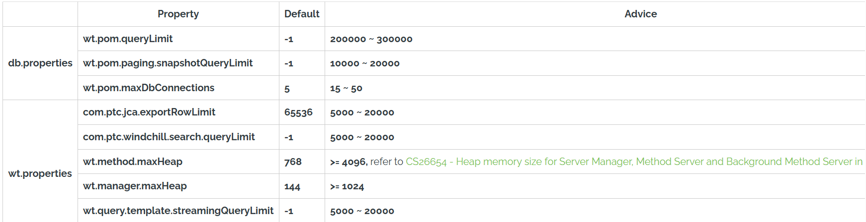

Types and Attributes Cache properties
Reference Articles:
Article - CS153338 - Windchill System Initial Performance Tuning
Article - CS277427 - Cache related sizing properties in Windchill PDMLink

Property-1: wt.cache.size.AclCache
- Below is the current value for this property in performance.xconf file.
  - <Property name="wt.cache.size.AclCache" overridable="true" targetFile="codebase/wt.properties" value="4000"/>
2. As mentioned in the Article - CS77589 this property value should be sized to twice the number of AdministrativeDomains that exist in the system.
3. AdministrativeDomains that exist in the system can be found from executing the following SQL.
select count(*) from AdministrativeDomain
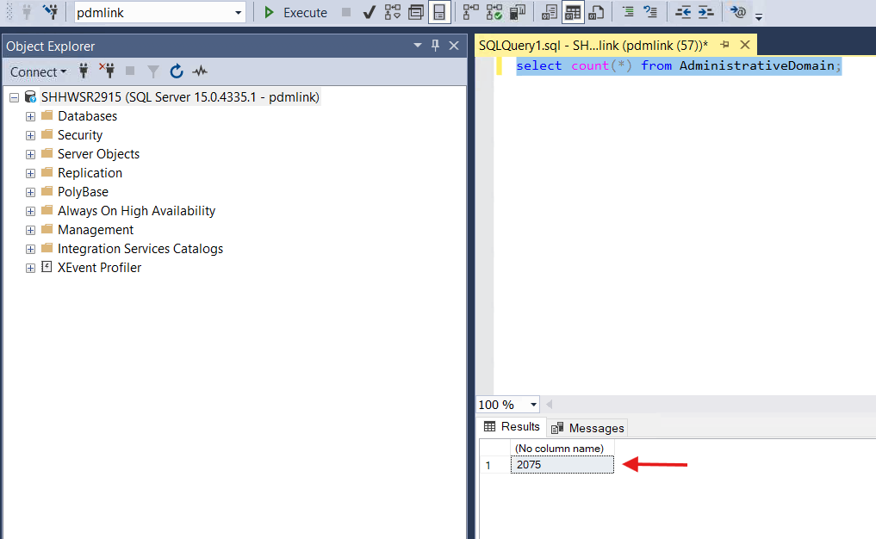

4. Update the property value as 4200 and execute xconfmanager -p from Windchill Shell as an admin.
- <Property name="wt.cache.size.AclCache" overridable="true" targetFile="codebase/wt.properties" value="4200"/>

Property-2: wt.cache.size.WTPrincipalCache
- Below is the current value for this property in performance.xconf file.

  - <Property name="wt.cache.size.WTPrincipalCache" overridable="true" targetFile="codebase/wt.properties" value="116430"/>

2. As mentioned in the Article - CS71489 cache sizing property wt.cache.size.WTPrincipalCache should be set using the formula (3*A)+(2*B)+C+(2*D).

  - A is the number of active users in the system (disabled=0)
  - B is the number of user-defined groups (status='public')
  - C is the number of system groups (status='system')
  - D is the number of active organizations in the system (disabled=0)
3. The below query will provide the result of the (3*A)+(2*B)+C+(2*D) formula for Windchill 12.0.1 and later releases.
select (select count(*)*3 as Total from WTUser where disabled=0) + (select count(*)*2 as Total from WTGroup where status='public' and disabled=0) + (select count(*) as Total from WTGroup where status='system' and disabled=0) + (select count(*)*2 as Total from WTOrganization where disabled=0) as total;
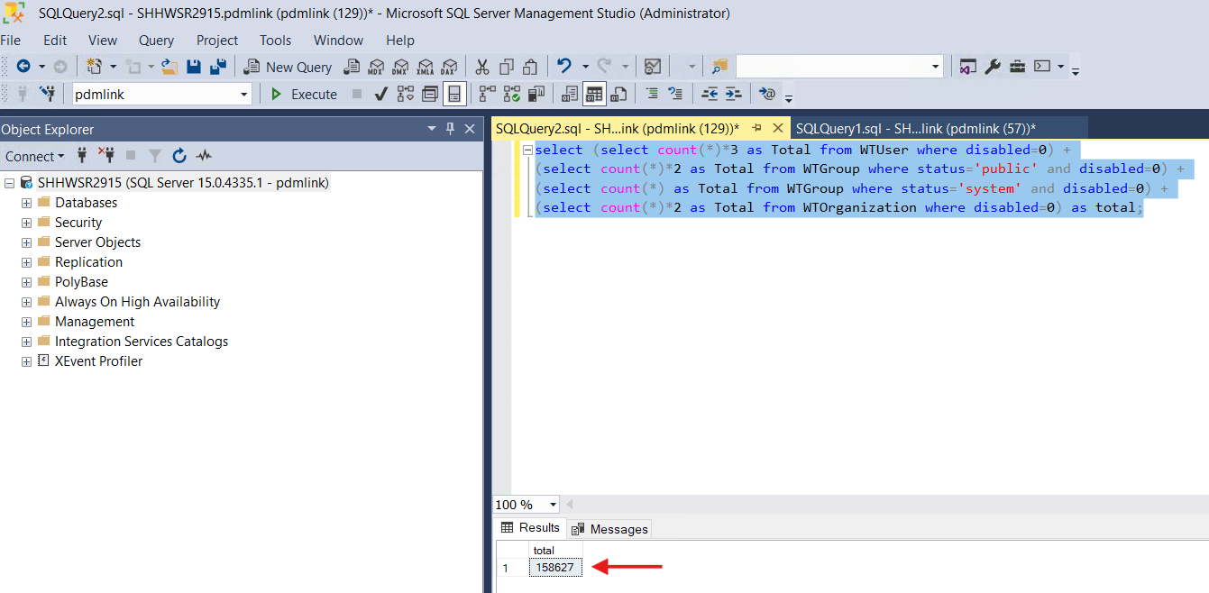
4. Update the property value as 158627 and execute xconfmanager -p from Windchill Shell as an admin.
- <Property name="wt.cache.size.WTPrincipalCache" overridable="true" targetFile="codebase/wt.properties" value="158627"/>

Property-3: wt.cache.CacheManager.summaryInterval
- Below Below is the current value for this property in performance.xconf file.

  - <Property name="wt.cache.CacheManager.summaryInterval" overridable="true" targetFile="codebase/wt.properties" value="100000"/>
2. This property was not available in the Article - CS277427 and also in the article it is mentioned that if the cache name does not have an article listed in the table, search knowledge base for the cache name to see if sizing guidelines already exist, or refer to CS239884How to configure and monitor Windchill Caches.
3. As per the Article - CS239884 if the property value is > 100000 it is mentioned to contact PTC Technical support.
4. We are ignoring this property as this property value was provided by PTC as a part of performance.xconf file.

Property-4: wt.cache.size.NotificationListCache
- Below is the current value for this property in performance.xconf file.

  - <Property name="wt.cache.size.NotificationListCache" overridable="true" targetFile="codebase/wt.properties" value="2000"/>
2. This property was not available in the Article - CS277427 and also in the article it is mentioned that if the cache name does not have an article listed in the table, search knowledge base for the cache name to see if sizing guidelines already exist, or refer to CS239884How to configure and monitor Windchill Caches.
3. As per the Article - CS239884 if the property value is <5000 it is suggested to double the value.
4. Update the property value with 4000 and execute xconfmanager -p from Windchill Shell as an admin.

Property-5: wt.cache.size.PagingSessionCache
- Below is the current value for this property in performance.xconf file.
  - <Property name="wt.cache.size.PagingSessionCache" overridable="true" targetFile="codebase/wt.properties" value="500"/>

2. This property was not available in the Article - CS277427 and also in the article it is mentioned that if the cache name does not have an article listed in the table, search knowledge base for the cache name to see if sizing guidelines already exist, or refer to CS239884 How to configure and monitor Windchill Caches.
3. As per the Article - CS239884 if the property value is <5000 it is suggested to double the value.
4. Update the property value with 1000 and execute xconfmanager -p from Windchill Shell as an admin.

Property-6: wt.cache.size.ReferenceCache
- Below is the current value for this property in performance.xconf file.
  - <Property name="wt.cache.size.ReferenceCache" overridable="true" targetFile="codebase/wt.properties" value="1000"/>

2. This property was not available in the Article - CS277427 and also in the article it is mentioned that if the cache name does not have an article listed in the table, search knowledge base for the cache name to see if sizing guidelines already exist, or refer to CS239884 How to configure and monitor Windchill Caches.
3. As per the Article - CS239884 if the property value is <5000 it is suggested to double the value.
4. Update the property value with 2000 and execute xconfmanager -p from Windchill Shell as an admin.

Property-7: wt.cache.size.RoleAccessCache
- Below is the current value for this property in performance.xconf file.

  - <Property name="wt.cache.size.RoleAccessCache" overridable="true" targetFile="codebase/wt.properties" value="5900"/>
2. As mentioned in the Article - CS246994 to size wt.cache.size.RoleAccessCache we need to use below formula.
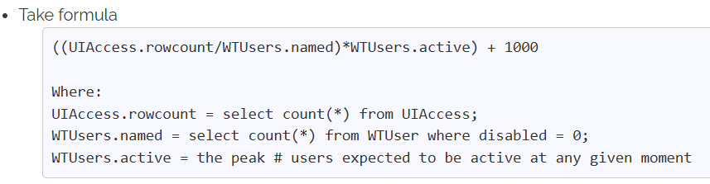
3. Below are the results for the above two sql queries.
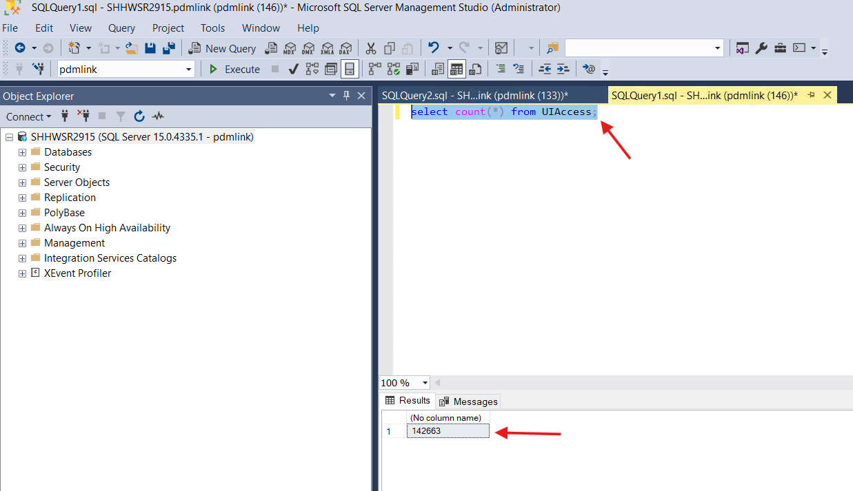
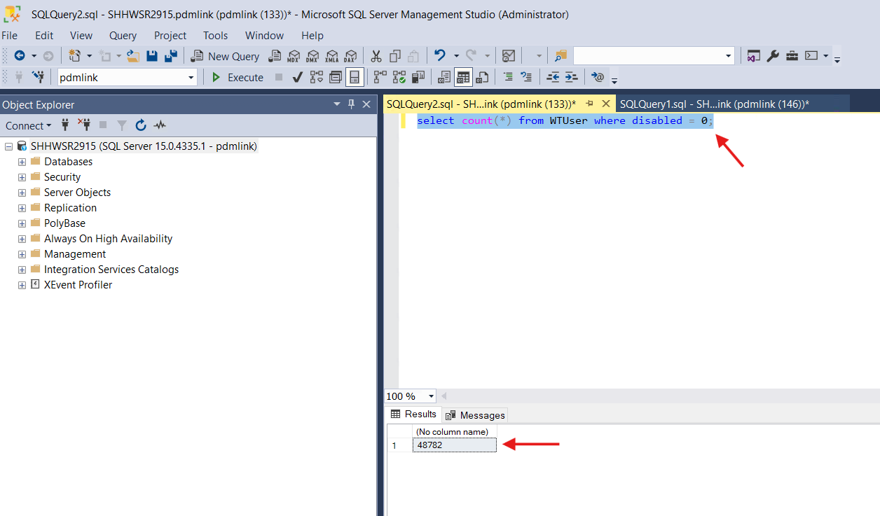

4. Calculated the value assuming the peak value of active users as 200 and the formula resulted the value as 1580.
5. Keeping the old value as the old value is higher than the new value.

Property-8: wt.cache.size.SessionCache
- Below is the current value for this property in performance.xconf file.

  - <Property name="wt.cache.size.SessionCache" overridable="true" targetFile="codebase/wt.properties" value="500"/>
2. As per the Article - CS332063 updating the property value to 2000 which is suggested by WCA.
3. Update the property value to 2000 and execute xconfmanager from Windchill Shell as an admin.

Property-9: wt.cache.size.StandardUfidSrvService$RemoteObjectIdCache
- Below is the current value for this property in performance.xconf file.

  - <Property name="wt.cache.size.StandardUfidSrvService$RemoteObjectIdCache" overridable="true" targetFile="codebase/wt.properties" value="4000"/>
2. As per Article - CS277427 and Article - CS97931 RemoteObjectId cache can be sized using one of the queries below.
select exp(sum(log(roic.TALLY))) as TALLY from
(select 2 as TALLY UNION ALL SELECT SUM(ss.TALLY ) FROM (
select count(*) TALLY from WTUser where disabled=0
UNION ALL
select count(*) TALLY from WTGroup where disabled=0 and internal=0
UNION ALL
select count(*) TALLY from WTOrganization where disabled=0) as ss) as roic;
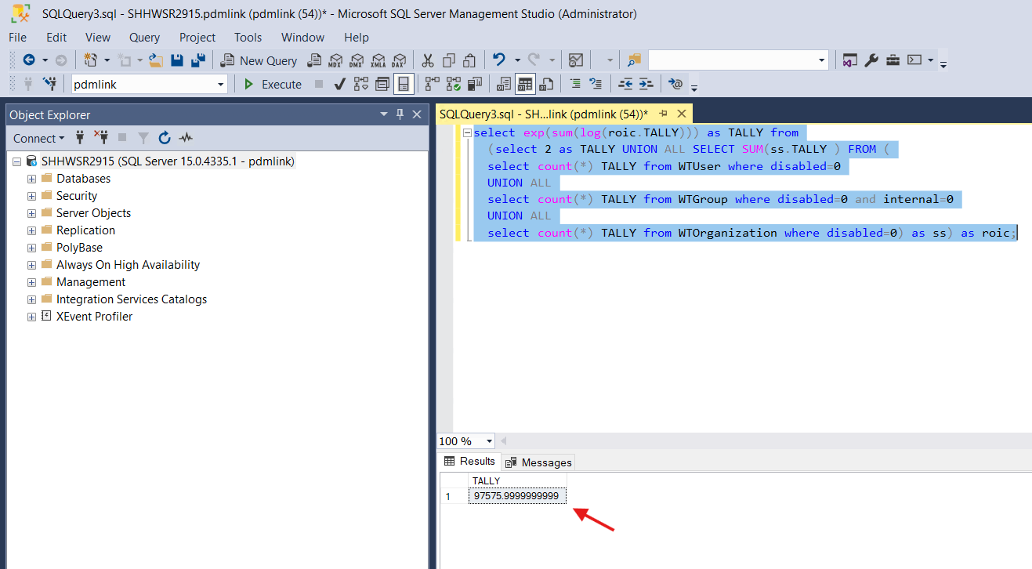

3. Update the value as 97575 and execute xconfmanager from Windchill Shell as an admin.

Property-10: wt.cache.size.StandardFvService$FvMountCache
- Below is the current value for this property in performance.xconf file.

  - <Property name="wt.cache.size.StandardFvService$FvMountCache" overridable="true" targetFile="codebase/wt.properties" value="500"/>
2. As per Article - CS277427 and Article - CS235423 it is recommended to set the wt.cache.size.StandardFvService$FvMountCache to a value higher than the value returned by below SQL query.
SELECT SUM(t.Total) AS FvMountCache FROM (
SELECT COUNT(*) AS Total FROM FvMount UNION ALL
SELECT COUNT(*) AS Total FROM RootMount) t;
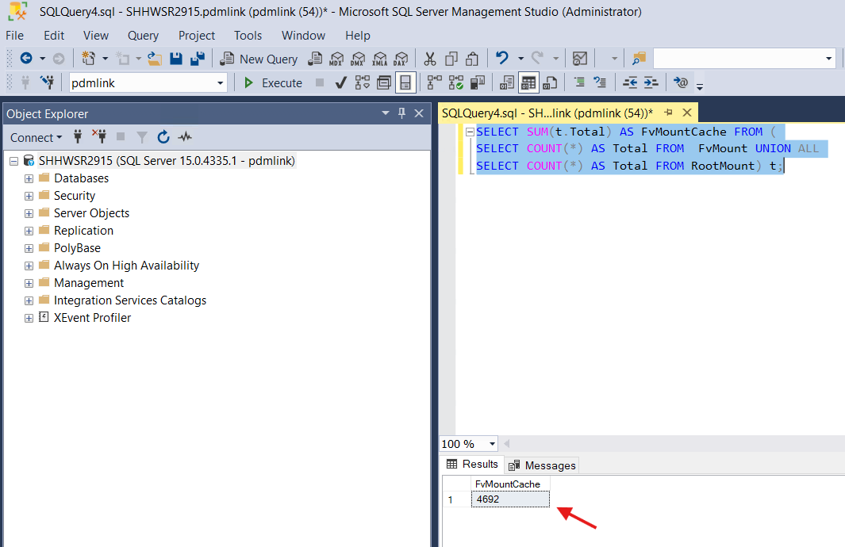

3. Update the value as 5000 and execute xconfmanager from Windchill Shell as an admin.

Property-11: wt.cache.size.StandardFvService$FvFolderCache
- Below is the current value for this property in performance.xconf file.

  - <Property name="wt.cache.size.StandardFvService$FvFolderCache" overridable="true" targetFile="codebase/wt.properties" value="500"/>
2. As per Article - CS277427 and Article - CS108045 it is recommended to set the wt.cache.size.StandardFvService$FvFolderCache to a value higher than the value returned by below SQL query.
SELECT SUM(t.Total) AS FvFolderCache FROM (
SELECT COUNT(*) AS Total FROM FvFolder UNION ALL
SELECT COUNT(*) AS Total FROM ReplicaFolder) t;
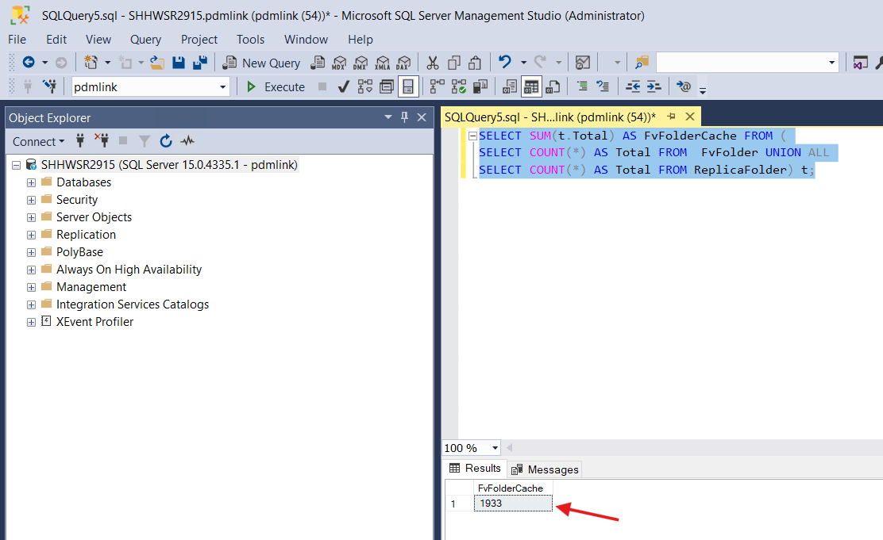

3. Update the value as 2500 and execute xconfmanager from Windchill shell as an admin.

Property-12: wt.cache.size.StandardFvService$ActiveFolderCache
- Below is the current value for this property in performance.xconf file.

  - <Property name="wt.cache.size.StandardFvService$ActiveFolderCache" overridable="true" targetFile="codebase/wt.properties" value="100"/>
2. As per Article - CS277427 and Article - CS100780 set wt.cache.size.StandardFvService$ActiveFolderCache to the value returned by the below SQL.
SELECT sum(t.Total) FROM ( SELECT count(*)*3 as Total FROM FvVault WHERE enabled=1 UNION ALL SELECT count(*)*3 as Total FROM ReplicaVault WHERE enabled=1) t ;
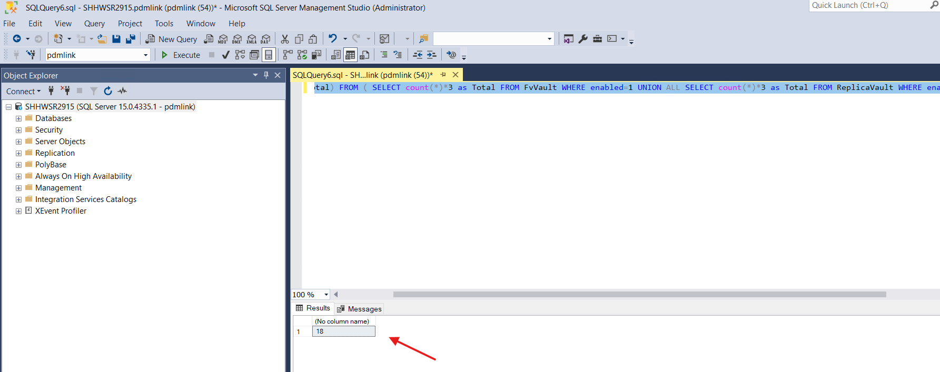

3. As the new value is lower than current value keeping the value as it is.

Property-13: wt.cache.size.StandardFvService$RootFolderCache
- Below is the current value for this property in performance.xconf file.

  - <Property name="wt.cache.size.StandardFvService$RootFolderCache" overridable="true" targetFile="codebase/wt.properties" value="400"/>
2. As per the Article - CS349423 run the below SQL Script and set the value of wt.fv.StandardFvService$RootFolderCache as the result.
SELECT 'wt.cache.size.StandardFvService$RootFolderCache='+ CAST((CASE WHEN 100 > count(*) * 2 THEN 100 ELSE count(*) * 2 END) AS VARCHAR(10)) from (select idA2A2 from pdmlink.FvMount union all select idA2A2 from pdmlink.FvFolder union all select idA2A2 from pdmlink.ReplicaFolder) as a;
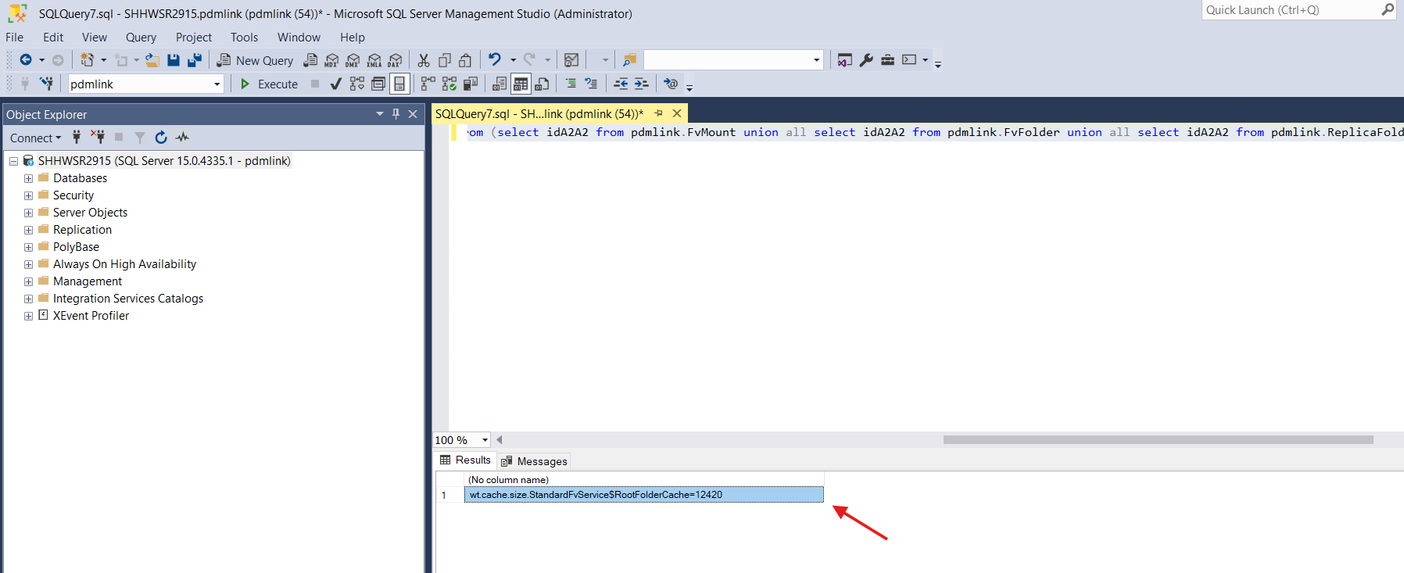

3. Update the value as 12420 and execute xconfmanager from Windchill shell as an admin.

Property-14, 15 & 16:
- wt.cache.size.TypeDefinitionCache2
- wt.cache.size.EnumerationDefinitionCache
- wt.cache.size.IBADefViewManager$IBADefViewCache
- Below are the current values for this property in performance.xconf file.

  - <Property name="wt.cache.size.TypeDefinitionCache2" overridable="true" targetFile="codebase/wt.properties" value="734"/>
  - <Property name="wt.cache.size.EnumerationDefinitionCache" overridable="true" targetFile="codebase/wt.properties" value="188"/>
  - <Property name="wt.cache.size.IBADefViewManager$IBADefViewCache" overridable="true" targetFile="codebase/wt.properties" value="1356"/>
2. As per the Article - CS177841 run the following query and implement the recommended wt.property values as shown in the resulting output.
SELECT 'com.ptc.core.lwc.PrimeTypeCache=true' AS CACHE_SIZE UNION ALL
SELECT 'wt.cache.size.StructEnumAttTemplateCache=' + CAST(MAX(g) AS VARCHAR(10)) AS CACHE_SIZE FROM
(SELECT 100 AS g UNION ALL SELECT COUNT(*) * 2 AS g FROM LWCStructEnumAttTemplate) m UNION ALL
SELECT 'wt.cache.size.EnumerationDefinitionCache=' + CAST(MAX(g) AS VARCHAR(10)) AS CACHE_SIZE FROM
(SELECT 100 AS g UNION ALL SELECT SUM(t.Total) * 2 AS g FROM(
SELECT COUNT(*) AS Total FROM LWCMasterEnumerationDefinition UNION ALL
SELECT COUNT(*) AS Total FROM LWCEnumerationDefinition) t) g UNION ALL
SELECT 'wt.cache.size.TypeDefinitionCache2=' + CAST(MAX(g) AS VARCHAR(10)) AS CACHE_SIZE FROM (SELECT 100 AS g UNION ALL SELECT COUNT(*) * 2 AS g FROM LWCTypeDefinition) m UNION ALL
SELECT 'wt.cache.size.TypeModificationCache=' + CAST(MAX(g) AS VARCHAR(10)) AS CACHE_SIZE FROM (SELECT 100 AS g UNION ALL SELECT COUNT(*) * 2 AS g FROM LWCTypeDefinition) m UNION ALL
SELECT 'wt.cache.size.PropertyDefinitionCache=' + CAST(MAX(g) AS VARCHAR(10)) AS CACHE_SIZE FROM (SELECT 100 AS g UNION ALL SELECT COUNT(*) * 2 AS g FROM LWCPropertyDefinition) m UNION ALL
SELECT 'wt.cache.size.IBADefViewManager$IBADefViewCache=' + CAST(MAX(g) AS VARCHAR(10)) AS CACHE_SIZE FROM
(SELECT 100 AS g UNION ALL SELECT SUM(t.Total) * 2 AS g FROM(
SELECT COUNT(*) AS Total FROM BooleanDefinition UNION ALL
SELECT COUNT(*) AS Total FROM FloatDefinition UNION ALL
SELECT COUNT(*) AS Total FROM IntegerDefinition UNION ALL
SELECT COUNT(*) AS Total FROM RatioDefinition UNION ALL
SELECT COUNT(*) AS Total FROM ReferenceDefinition UNION ALL
SELECT COUNT(*) AS Total FROM StringDefinition UNION ALL
SELECT COUNT(*) AS Total FROM TimestampDefinition UNION ALL
SELECT COUNT(*) AS Total FROM UnitDefinition UNION ALL
SELECT COUNT(*) AS Total FROM URLDefinition) t) g UNION ALL
SELECT 'wt.cache.size.ClassificationEnumCache=' + CAST(MAX(g) AS VARCHAR(10)) AS CACHE_SIZE FROM
(SELECT 1000 AS g UNION ALL SELECT COUNT(*) * 2 AS g FROM LWCStructEnumAttTemplate) t;

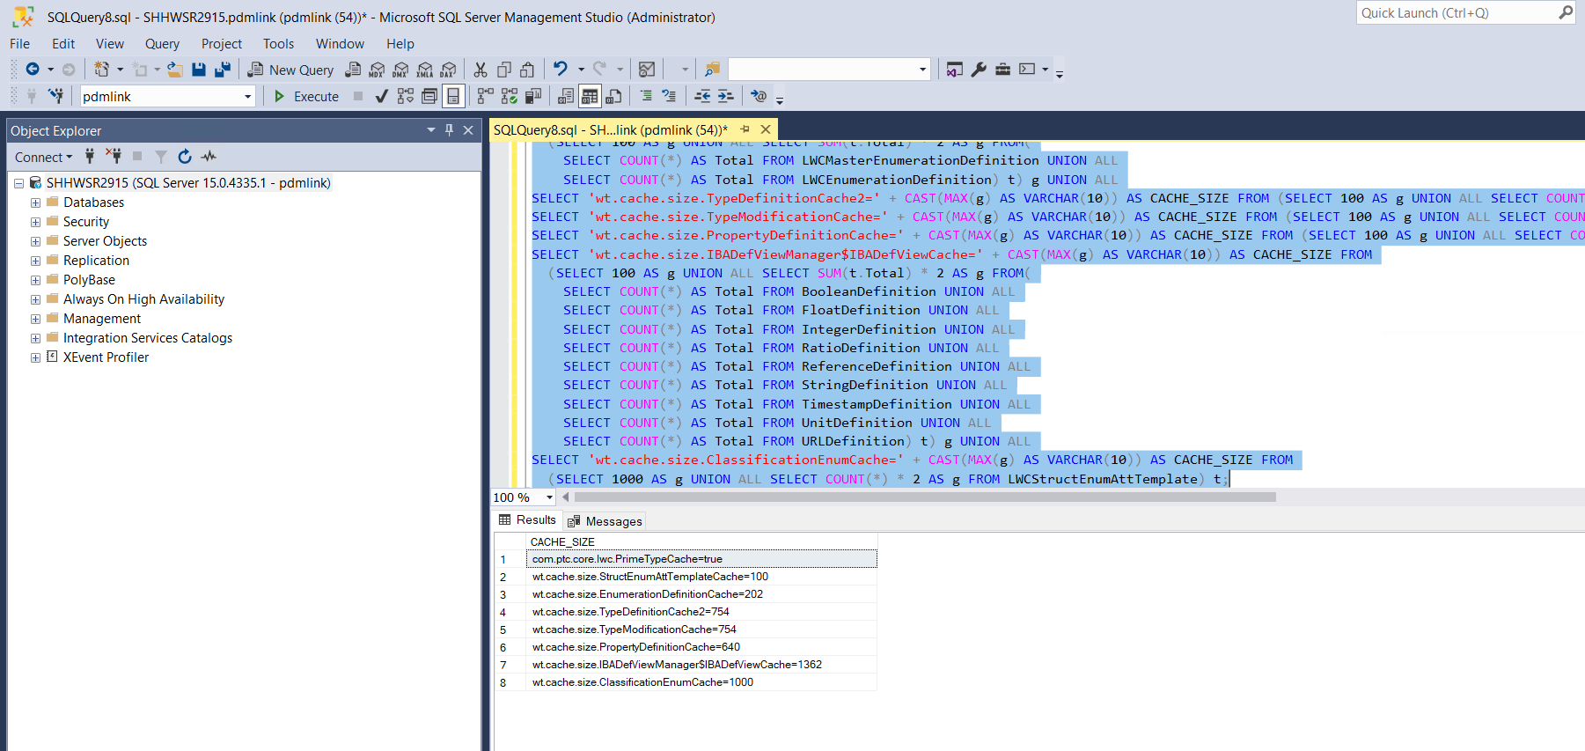

3. Update the property values as per the result and execute xconfmanager from Windchill Shell as an admin.

Property-17: wt.admin.cache.maxDomains
- Below is the current value for this property in performance.xconf file.

  - <Property name="wt.admin.cache.maxDomains" overridable="true" targetFile="codebase/wt.properties" value="2000"/>
2. Keep the value as it is, as this is a custom property that was suggested by PTC to set the value as 2000 and also the current WCA suggested the same value 2000.

Property-18: wt.cache.size.PreferenceCache
- Below is the current value for this property in performance.xconf file.

  - <Property name="wt.cache.size.PreferenceCache" overridable="true" targetFile="codebase/wt.properties" value="50000"/>
2. As per the Article - CS277427 and Article - CS27612 wt.cache.size.PreferenceCache can be manually sized using the following SQL.
WITH C AS ( SELECT COUNT(*) AS rowsCounted FROM PreferenceInstance ) SELECT 'wt.cache.size.PreferenceCache=' + CAST(CASE WHEN C.rowsCounted < 5000 THEN 5000 WHEN C.rowsCounted > 50000 THEN 50000 ELSE C.rowsCounted END AS VARCHAR(10)) AS CACHE_SIZE FROM C;
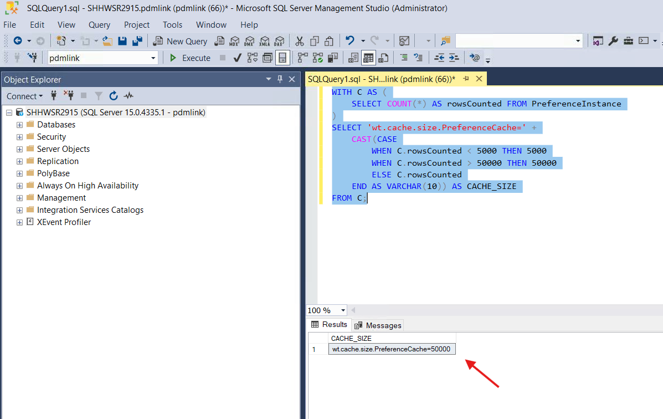
3. Both current and new values, so not making any change to the property.

Property-19: wt.services/rsc/default/ObjectReferenceCacheTable/ContainerCache.Size/null/0
- Below is the current value for this property in performance.xconf file.

  - <Property name="wt.services/rsc/default/ObjectReferenceCacheTable/ContainerCache.Size/null/0" overridable="true" targetFile="codebase/service.properties" value="1012"/>
2. As per Article - CS277427 and Article - CS299894 to manually size the ContainerCache run the following SQL.
SELECT SUM(c.total) from ( SELECT COUNT(*) AS total FROM PDMLinkProduct UNION ALL SELECT COUNT(*) AS total FROM Project2 UNION ALL SELECT COUNT(*) AS total FROM WTLibrary) c;
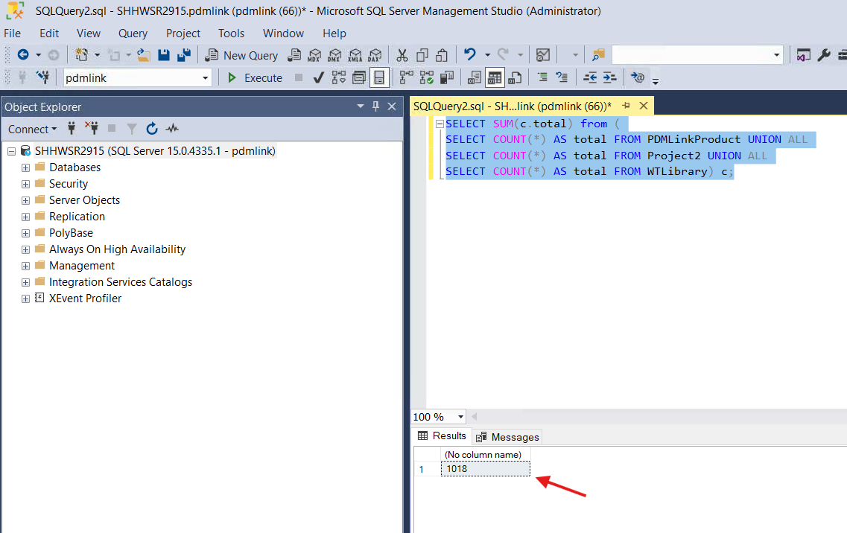
3. Update the value as 1018 and execute xconfmanager from Windchill Shell as an admin.

Property-20: wt.services/rsc/default/ObjectReferenceCacheTable/ContainerTeamCache.Size/null/0
- Below is the current value for this property in performance.xconf file.

  - <Property name="wt.services/rsc/default/ObjectReferenceCacheTable/ContainerTeamCache.Size/null/0" overridable="true" targetFile="codebase/service.properties" value="1012"/>
2. As per Article - CS277427 and Article - CS299450 to manually size the ContainerTeamCache run the following SQL.
- SELECT COUNT(*) FROM ContainerTeam;
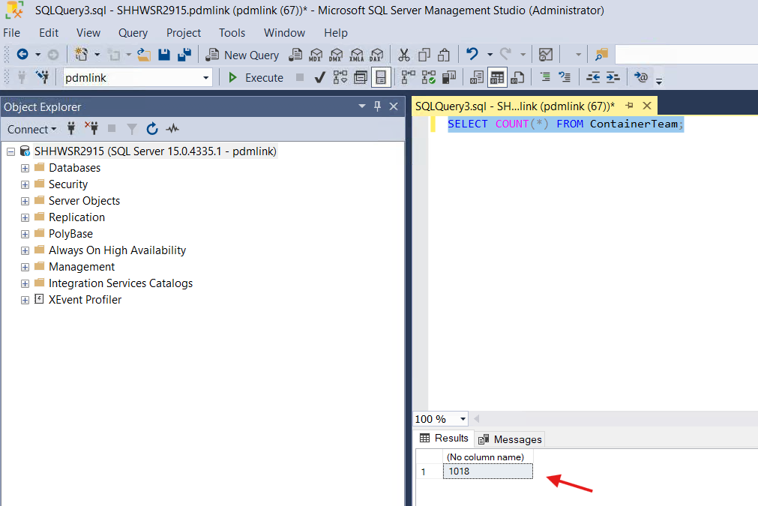

3. Update the value as 1018 and execute xconfmanager from Windchill Shell as an admin.

Vault Tuning
- Below are the properties available in performance.xconf related to vaults.
- <Property name="wt.fv.forceContentToVault" overridable="true" targetFile="codebase/wt.properties" value="true"/>
- <Property name="wt.fv.useVaultsForAllContent" overridable="true" targetFile="codebase/wt.properties" value="false"/>
- <Property name="wt.fv.useFvFileThreshold" overridable="true" targetFile="codebase/wt.properties" value="true"/>
- <Property name="wt.fv.fvFileThreshold" overridable="true" targetFile="codebase/wt.properties" value="50000"/>
2. These properties are as per the expectation as per Article - CS209705

Index Tuning
- Below are the properties available in performance.xconf related to indexing.
- <Property name="wt.index.maxContentSize" overridable="true" targetFile="codebase/wt.properties" value="20971520"/>
- <Property name="wt.index.maxDocumentSize" overridable="true" targetFile="codebase/wt.properties" value="20971520"/>
- <Property name="wt.index.indexingWorkingCopy" overridable="true" targetFile="codebase/wt.properties" value="false"/>
2. As per the Article - CS230028 existing values looks good, so not making any changes.

Database Tuning
- As per Article - CS153338 and Article - CS262774 download the below script.
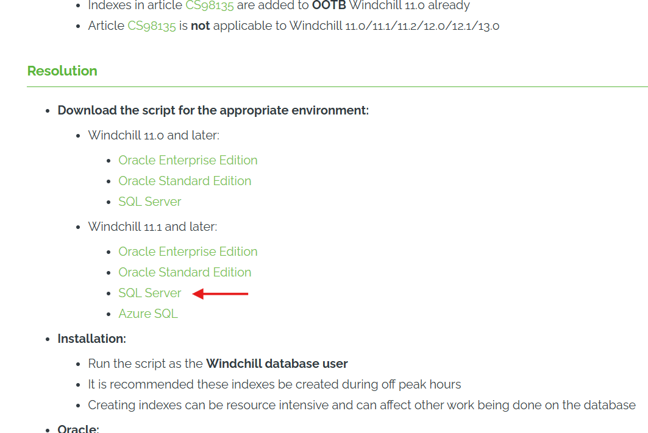

2. Extract the zip file and open the .sql file to modify the script with Text Editor to replace <YOUR_SCHEMA_NAME> with your own schema name pdmlink.

3. Execute the command with Windchill DB User.
4. Query got executed with below errors.
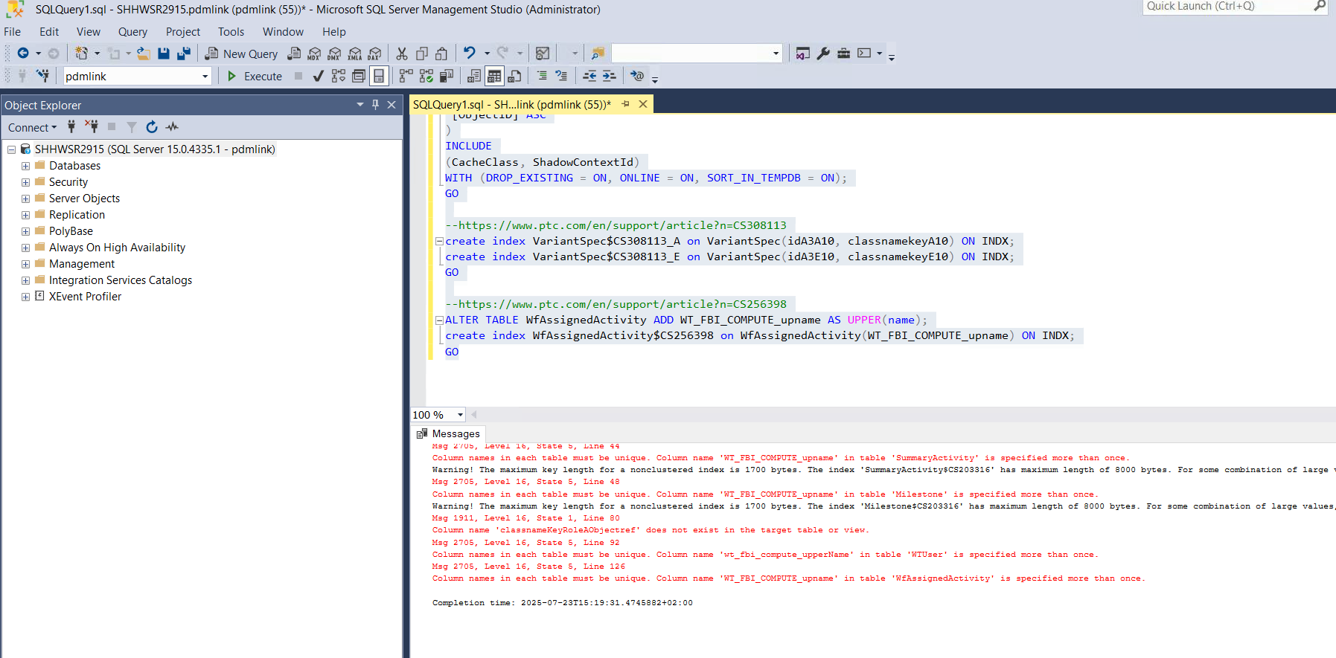

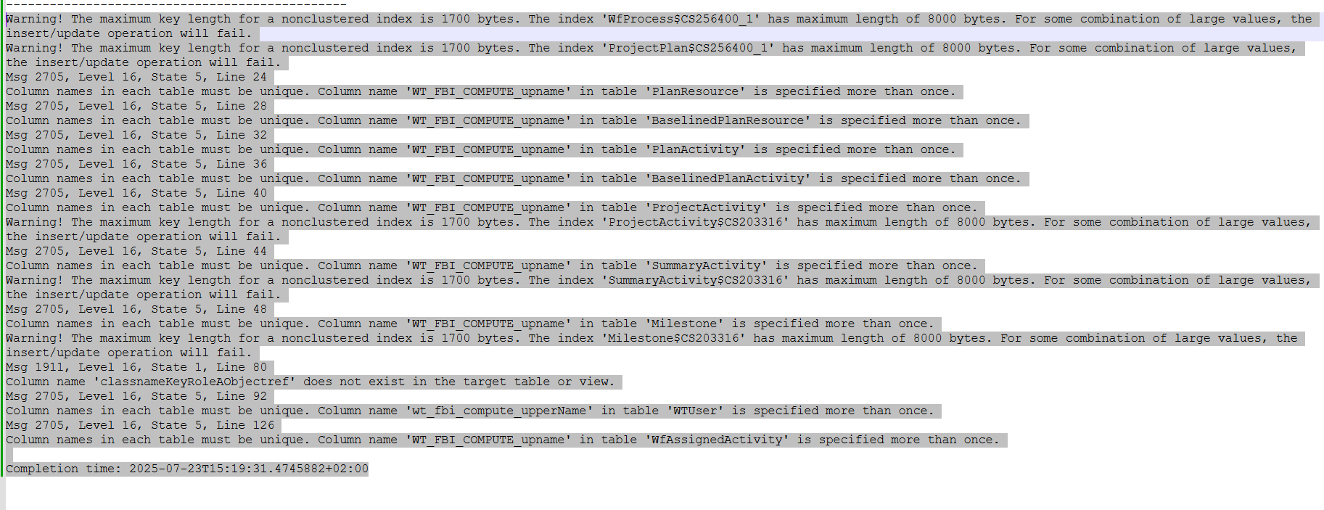

Warning! The maximum key length for a nonclustered index is 1700 bytes. The index 'WfProcess$CS256400_1' has maximum length of 8000 bytes. For some combination of large values, the insert/update operation will fail.
Warning! The maximum key length for a nonclustered index is 1700 bytes. The index 'ProjectPlan$CS256400_1' has maximum length of 8000 bytes. For some combination of large values, the insert/update operation will fail.
Msg 2705, Level 16, State 5, Line 24
Column names in each table must be unique. Column name 'WT_FBI_COMPUTE_upname' in table 'PlanResource' is specified more than once.
Msg 2705, Level 16, State 5, Line 28
Column names in each table must be unique. Column name 'WT_FBI_COMPUTE_upname' in table 'BaselinedPlanResource' is specified more than once.
Msg 2705, Level 16, State 5, Line 32
Column names in each table must be unique. Column name 'WT_FBI_COMPUTE_upname' in table 'PlanActivity' is specified more than once.
Msg 2705, Level 16, State 5, Line 36
Column names in each table must be unique. Column name 'WT_FBI_COMPUTE_upname' in table 'BaselinedPlanActivity' is specified more than once.
Msg 2705, Level 16, State 5, Line 40
Column names in each table must be unique. Column name 'WT_FBI_COMPUTE_upname' in table 'ProjectActivity' is specified more than once.
Warning! The maximum key length for a nonclustered index is 1700 bytes. The index 'ProjectActivity$CS203316' has maximum length of 8000 bytes. For some combination of large values, the insert/update operation will fail.
Msg 2705, Level 16, State 5, Line 44
Column names in each table must be unique. Column name 'WT_FBI_COMPUTE_upname' in table 'SummaryActivity' is specified more than once.
Warning! The maximum key length for a nonclustered index is 1700 bytes. The index 'SummaryActivity$CS203316' has maximum length of 8000 bytes. For some combination of large values, the insert/update operation will fail.
Msg 2705, Level 16, State 5, Line 48
Column names in each table must be unique. Column name 'WT_FBI_COMPUTE_upname' in table 'Milestone' is specified more than once.
Warning! The maximum key length for a nonclustered index is 1700 bytes. The index 'Milestone$CS203316' has maximum length of 8000 bytes. For some combination of large values, the insert/update operation will fail.
Msg 1911, Level 16, State 1, Line 80
Column name 'classnameKeyRoleAObjectref' does not exist in the target table or view.
Msg 2705, Level 16, State 5, Line 92
Column names in each table must be unique. Column name 'wt_fbi_compute_upperName' in table 'WTUser' is specified more than once.
Msg 2705, Level 16, State 5, Line 126
Column names in each table must be unique. Column name 'WT_FBI_COMPUTE_upname' in table 'WfAssignedActivity' is specified more than once.
Completion time: 2025-07-23T15:19:31.4745882+02:00

4. Logged a PTC case - PTC Case: C17885364 to get the assistance and PTC confirmed that there are no issues with these errors.
5. Stop Windchill, clean cache and restart Windchill.

